Year 1 Maths Medium Term Plan 2021-2022

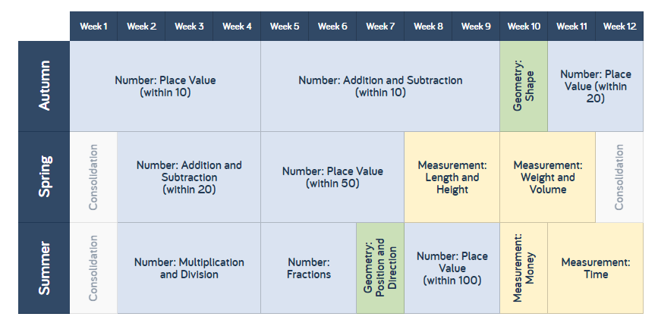
Autumn term
Number and Place Value within 10 | Number: Addition and Subtraction within 10 | Geometry: Shape | Number: Place value within 20
- Sorting Objects  - Counting objects  - Representing objects  - Count, read and write numbers forwards to 10  - Count, read and write numbers backwards to 10  - Count one more  - Count one less  - One-to one correspondence to start to compare groups  - Compare groups using language such as equal, more/ greater, less/fewer  - Introduse < > and = symbols  - Compare numbers  - Order groups of objects  - Order numbers  - Ordinal numbers 1st, 2nd, 3rd  - The number line | - Part-whole model  - Addition symbol  - Fact families- addition facts  - Find number bonds for numbers within 10  - Systematic methods for number bonds within 10  - Number bonds to 10  - Compare number bonds  - Addition- adding together  - Addition adding more  - Finding a part  - Subtraction- taking away, how many left?  - Subtraction symbol  - Subtraction-finding a part, breaking apart  - Fact families- the 8 facts  - Subtraction- counting back | - Recognise and name 3-D shapes  - Sort 3D shapes  - Recognise and name 2D shapes  - Patterns with 3D and 2D shapes | - Count forwards and backwards and write numbers to 20 in numerals and words  - Numbers from 11 to 20  - Tens and Ones  - Count one more and less  - Compare groups of objects  - Compare numbers  - Order groups of objects  - Order numbers
Number: Addition and Subtraction within 20 | Number: Place value within 50 | Measurement: Length and height | Measurement: Weight and Volume
- Add by counting on  - Add ones using number bonds  - Find and make number bonds  - Add by making 10  - Subtraction not crossing 10  - Subtraction crossing 10  - Related facts  - Compare number sentences | - Counting to 50 by making 10s  - Numbers to 50  - Counting forwards and backwards within 50  - Tens and Ones  - Represent numbers to 50  - One more and one less than a number  - Compare objects within 50  - Compare numbers within 50  - Count in 2s  - Count in 5s | - Compare lengths  - Compare heights  - Measuring lengths  - Introducing the ruler  - Adding lengths  - Subtracting lengths | - Introduce weight and mass  - Measure mass  - Compare mass  - Weight and mass problems  - Introduce capacity and volume  - Measure capacity  - Compare capacity
Spring Term

Year 1 Maths Medium Term Plan 2021-2022
Summer Term
Number: Multiplication and Division | Number: Fractions | Geometry: Position and Direction | Number: Place Value within 100 | Measurement: Money | Measurement: Time
- Count in 2s  - Count in 5s  - Count in 10s  - Make equal groups  - Add equal groups  - Make arrays  - Make doubles  - Grouping  - Sharing | - Making a half  - Making a whole  - Find a half  - Find half of a quantity  - Find a quarter  - Find a quarter of a quantity | - Describe turns  - Describe positions | - Counting to 100 by making 10s  - Counting to 100  - Counting forwards and backwards within 100  - The 100 square  - Partitioning numbers  - Comparing numbers  - Ordering numbers  - One more or less | - Recognising coins  - Recognising notes  - Counting in coins | - Before and after  - Dates  - Time to the hour  - Time to the half hour  - Writing time  - Comparing time

