St. George’s Church of England Primary School

September 2026

Clubs Term 1

Please find the after-school sports clubs on offer for Term 1. School Clubs will run each week from Monday 7st September to Friday 23rd October.

Please ensure we receive your response by 5pm on Friday 4th September so that we can allocate spaces. Once you have filled in your form your child has a space at the club unless we contact you to say the club is full.

To increase our club offer, we have a number of outside providers who will be running clubs for us this year in addition to teacher led provision.

Day | Time | Club | Year Group
Monday | 3.30 – 4.15 p.m. | Wildlife club  Mrs Sutcliffe | 3 & 4
Monday | 3.30 – 4.15 p.m. | Netball  Mrs Basden | 5 & 6
Tuesday | 3.30-4.15pm. | Wildlings workshop (Art)  Portia (fee paying) | 3,4,5&6
Wednesday | 3.30-4.15pm | Cornerstone Club  St George’s Church | 3,4,5&6
Wednesday | 3.30-4.15pm. | Welland Dance Club  Miss Carly (fee paying) | 2,3,4,5&6
Thursday | 12-12.30pm  In Class 5 room | Choir  Miss Gibney | 4,5 & 6

Please click on the link to google forms to express your interest in the clubs on offer from school staff.

https://forms.gle/Di2kVautQsKkkt127

Please see links below for clubs led by other providers as these are fee paying and require you to contact them directly to book places.

Welland Dance Club Years 2-6
Welland School of Dance is coming to St George’s! Join Miss Carly at this new dance club where each week there will be a mix of contemporary dance styles with performance opportunities throughout the year. Suitable for Years 2-6. ‘Once you have started an account with us then click ‘Classes’ and then click ‘St George’s WPAC’, this will add your child to the register.’
https://app.gostudiopro.com/online/wellandportal
Ballet & Dance School || Welland School of Dancing

Wildling Workshops Art Club ran by Portia
These fun & relaxed artist-led workshops aim to capture your child’s imagination, allowing their inner artist to shine. All abilities are welcome within the KS2 classes (Years 3-6)

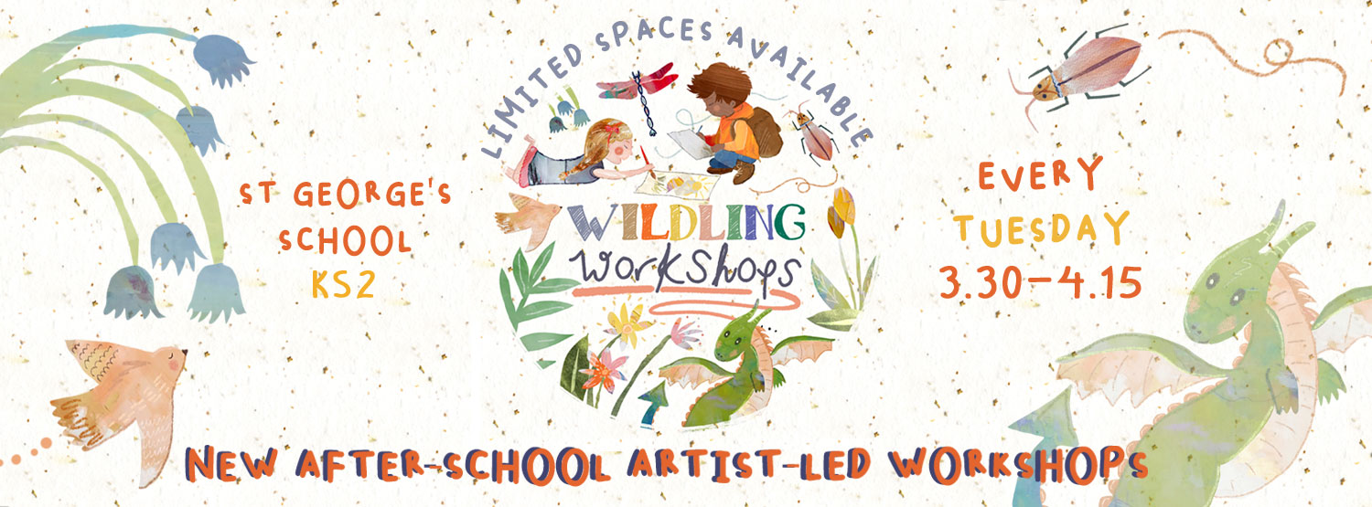

The Booking link is: Wildling Workshops

We are really pleased to have such a broad offer and hope that lots of children will enjoy the sessions.

Yours faithfully,

Mrs R Fleming
Head of School

